COLLEGE BUSINESS EDUCATION
DAR ES SALAAM

GROUP ASSIGNMENT
COURSE: BACHELOR DEGREE IN INFORMATION TECHNOLOGY.
MODULE: Database Management and Administration
MODULE CODE: ITU07307.
FACILITATOR: Kikwembo Mlekwa.
YEAR OF STUDY: Second Year.
SEMESTER : 1st
ACADEMIC YEAR: 2025/2026.
STREAM: TNC.
GROUP NUMBER EIGHT.
GROUP MEMBERS
SN | FULL NAME | REGISTRATION NUMBER
1 | FATMA MOHAMED MUSA | 03.9607.02.01.2024
2 | FRANCE GAUFRID FUSSY | 03.3154.01.01.2024
3 | GOODLUCK JULIUS ABRAHAM | 03.1535.02.01.2024
4 | JOSHUA M SAMWEL | 03.4813.02.01.2024
5 | REGINA CHARLES | 03.4512.02.01.2024
6 | VICTORIA EMANUEL MBOKO | 03.3559.01.01.2022
7 | WILSON MAPE MAPANDE | 03.4228.02.01.2024

AIRPORT DEPARTMENTS AND THERE OPERATIONS
Department/Agency | Base | Duties | Objectives
- CUSTOMS | - At departure Lounge: | - Checks on illegal exportation of goods  - Checks on illegal exportation of Currency  - Checks on illegal exportation of Drugs  - Checks on illegal exportation of Arms | - To protect revenue, lev,y etc., compile statistics.  - To protect territorial integrity (economy)  - To protect the security of the citizens of destination.  - To protect revenue (customs duty and sales tax)  - To compile statistics – trade trends.
 | - At Arrival Lounge: | - Checks on illegal importation of goods | - To protect the national morals by seizing pornographic materials.  - To protect the national healthy by seizing dangerous drugs.  - To protect national security by seizing illegal importation of arms.
 | - At Cargo Terminal | Check on the legal importation /exportation of goods. | - To raise revenue – as Customs & Sales Tax  - To compile statistical data – trade trends.
- IMMIGRATION | - At Departure/Arrival lounge | - Check on the movement of passengers | - To protect national integrity/Security by ensuring that passengers are authorized entry/ exit at origination/destinations.
- HEALTH | - Arrival Lounge | - Detain and quarantine passengers without valid medical/health certificates; and  - Inoculates or treats them. | - To protect the national health of the host country  - To protect the health of the nation by ensuring that health formalities of Imports/exports are complied with.
- CIVIL AVIATION | - At Control Tower  - Lays down rules of operators, crew, aircraft airworthiness, aerodrome worthiness etc.) | - Controls the movements of aircraft in the skies | - Security of aircraft and occupants assured  - Protects the national integrity of National airspace
- METEOROLOGICAL DEPARTMENT | - At Airport | - Briefs operating crew on the weather conditions of its flight path | - Security and safety of aircraft passengers
- FIRE BRIGADE | - At Airport | - Maintain fire services | - Safety of aircraft and occupants.
- AIRPORT AUTHORITY | - At Airport | - Maintain airports to serviceable Standards as directory by the Civil Aviation.  - Maintain statistics of the traveling public. | - Safety of aircraft and occupants.  - Determine long and short time protectorates for expansions and improvements of aircraft for the safety of passengers.
- POLICE/MILITARY | At Airport | - Maintain law and order | - Protect territorial integrity  - Protect and ensure security of airport users and aircraft.
- BANKS/BUREAU DE CHANGE | At Airport | - Money exchangers | - Protect territorial integrity by maintaining proper and legal money exchanges.

DATA MODELING
From the Airport Operations The following are the important data used to create a database

Entinty: Airlines
- Airline_Id(PK)INT
- Name(VARCHAR)
- Registration_number(VARCHAR)

Entinty: Aircraft
Attributes:
- Aircraft_Id(PK)INT
- Registration number(VARCHAR)
- Aircraft_type(VARCHAR)
- Airline_Id(INT)

Entinty: FlightInformation
Attributes:
- Flight_Id(PK)INT
- Flight number(VARCHAR)
- Depature_Airport(VARCHAR)
- Destination_Airport(VARCHAR)
- Route(VARCHAR)
- Departure_time(Datetime)
- Arrival_Time(Datetime)
- AircraftId(INT)

Entinty: Passangers
Attributes:
- Passenger_Id(PK)INT
- Name(VARCHAR)
- Address(VARCHAR)
- Email(VARCHAR)
- Phone(VARCHAR)
- Gender(VARCHAR)
- Nationality(VARCHAR)
- National_ID(VARCHAR)

Entinty: Tickets
Attributes:
- Ticket_Id(PK)INT
- Flight_Id(INT)
- Passenger_Id(INT)
- SeatNumber(VARCHAR)
- TravelType(VARCHAR)

Entinty: ImmigrationRecords
Attributes:
- Migration_Id(PK)INT
- Ticket_Id(INT)
- Passenger_Id(INT)
- PassportNumber(VARCHAR)
- VisaNumber(VARCHAR)
- Type(VARCHAR)
- ClearanceDate(DateTime)

Entinty: Luggages
Attributes:
- Luggage_Id(PK)INT
- Ticket_Id(INT)
- Weight(INT)
- Luggage_type(VARCHAR)
- Status(VARCHAR)
- Date(DateTime)

Entinty: Cargos
Attributes:
- Cargo_Id(PK)INT
- Flight_Id(INT)
- SenderName(VARCHAR)
- ReciverName(VARCHAR)
- CargoWeight(INT)
- CargoType(VARCHAR)
- Date(DateTime)

Entinty: Inspections
Attributes:
- Inspection_Id(PK)INT
- Luggage_Id(INT, nullable)
- Cargo_Id(INT, nullable)
- Inspection_Type(VARCHAR)
- InspectionDate(Date)
- Status(VARCHAR)
Entinty: Departments
Attributes:
- Department_Id(PK)INT
- Name(VARCHAR)

Entinty: Positions
Attributes:
- Position_Id(PK)INT
- Name(VARCHAR)

Entinty: Roles
Attributes:
- Roles_Id(PK)INT
- Name(VARCHAR)

Entinty: Staffs
Attributes:
- Staff_Id(PK)INT
- Name(VARCHAR)
- Email(VARCHAR)
- Phone(VARCHAR)
- Department_Id
- Role_Id(INT)
- Position_Id(INT)
Entity: Health
Attributes:
- ID
- passenger_ID
- status
- quarantine

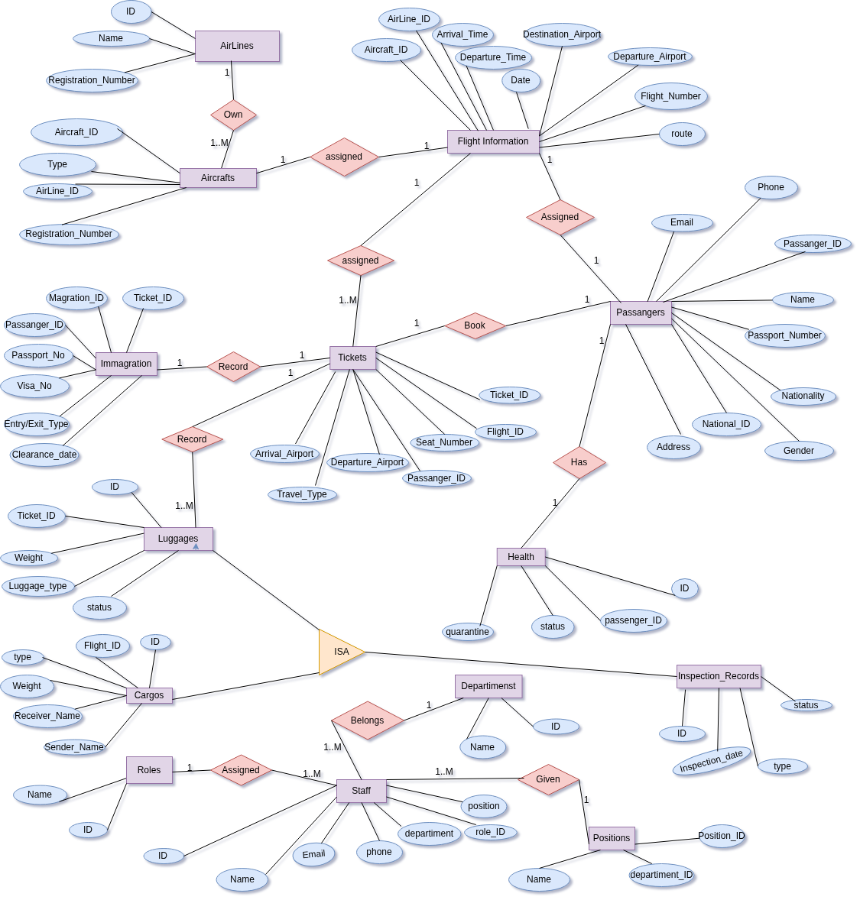
ER Diagrams

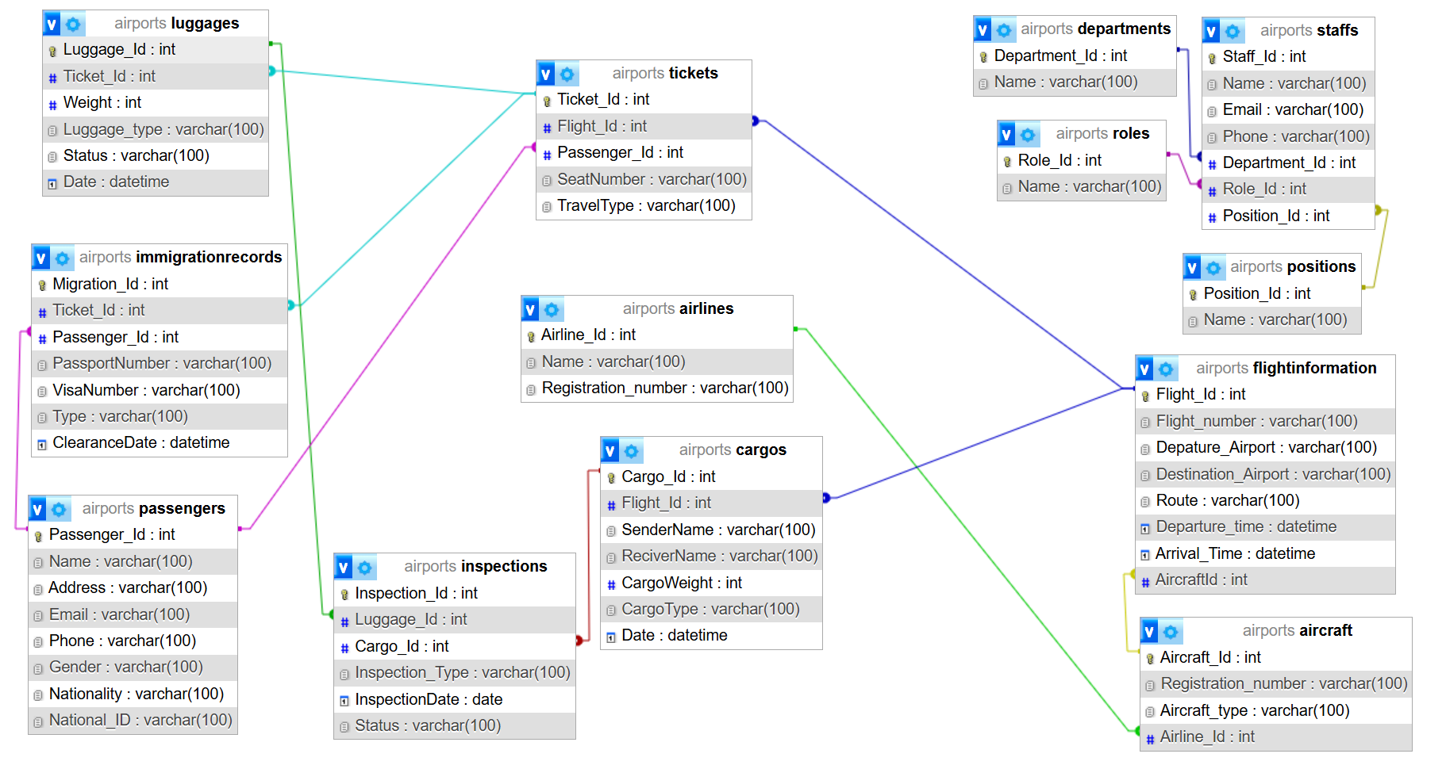
DATABASE SCHEMA

